

Omni Reach – Release Note
Date: 25/11/2025
Release date: 02/12/2025

Introduction
The document communicates the new features and changes in OMNI Reach release.

About the Release
Changes made include:

Forward To Email Analytics Webhook Event
There is a new Activity Type for Forward Conversation to Email: ForwardedToEmail
There is an additional property on these messages: ForwardedToEmailAddress
{
"Username": "00000000-0000-0000-0000-000000000000",
"ConversationId": 2109466,
"CampaignId": 1250,
"Timestamp": "2025-11-05T17:48:21.8422059+00:00",
"Channel": "Email",
"ConversationActivityType": "ForwardedToEmail",
"ForwardedToEmailAddress": "carl@email.co.uk"
}

Monthly Agent Reporting has an Auto Resolved column
Reports -> Agent -> ‘Monthly’ tab
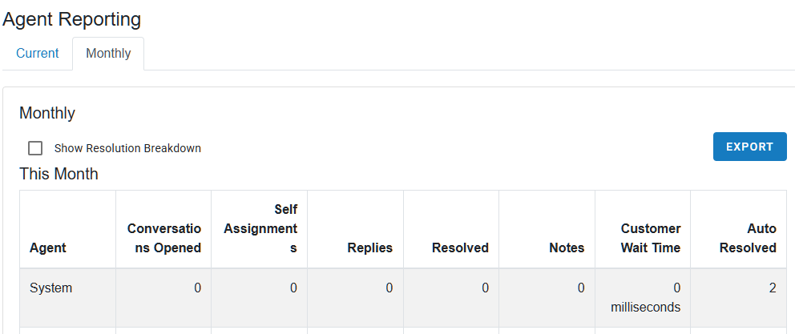

Most Reports have an Export button
The downloaded file will be the contents of the report exported as a CSV format

If an upload fails due to no “from email” or no “SMS sending number” there will now be a report entry on the daily reports
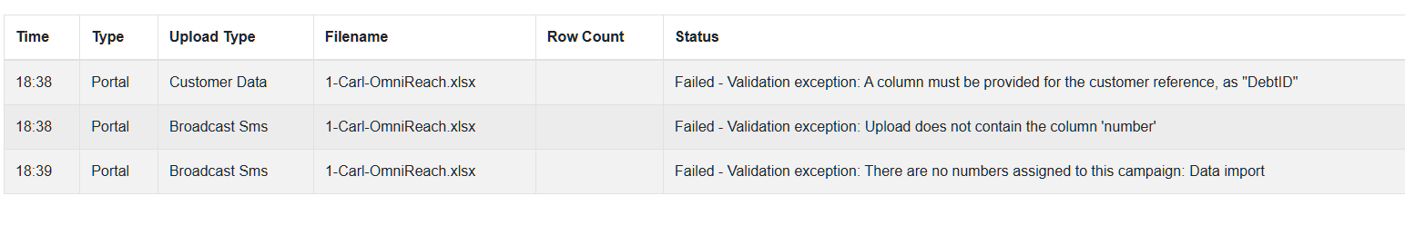

5xx Failures during identification via API handling
The message is processed and added to the chat and a note is sent to the agent.
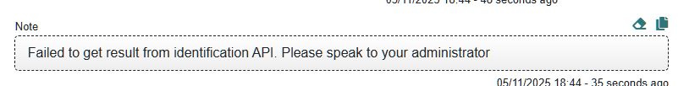

HOTFIX: Issue with Tag Processors Auto Resolving conversations
Conversations were not being auto resolved when triggered by a tag processor

HOTFIX: Issue with Null Tags
No tags were being applied

HOTFIX: Added Customer Reference to ‘CustomerIdentified’ Conversation Activity
The Webhook for CustomerIdentified now includes the NewCustomerRef property
{
"Username": "",
"ConversationId": 2109535,
"CampaignId": 1200,
"Timestamp": "2025-11-05T18:48:03.3230951+00:00",
"Channel": "None",
"ConversationActivityType": "CustomerIdentified",
"NewCustomerRef": "1234567890-api"
}

BUGFIX: Corrected Agent Status on Team Manager dashboard
Agent is now marked as Active when viewing a conversation

Customer Reminders always happen after Identification
Previously if the customer abandoned the chat after Identification or Verification any reminders and auto resolution settings were not being applied. Currently if a customer abandons a chat and the campaign is set to auto resolve conversations, then the reminders will be sent and the conversation will be auto resolved.

BUGFIX & UI Change: The control to add tags has changed
Previously, during busy periods, the tag interface would clear without user input.

Known Bugs and Limitations
None

