

Omni Reach – Release Note
Release notes Dated: 07/04/2026
Physical release date 20/04/2026

Introduction
The document communicates the new features and changes in OMNI Reach release.

About the Release
Changes made include:

Bugfix – Transcript reports will show correct assignment time for emails

Bugfix – Messages from the bot use a different time precision to customer messages
This could put messages out of order in the transcripts

Display a timer on the agent pause screen with an optional limit
New Pause Screen: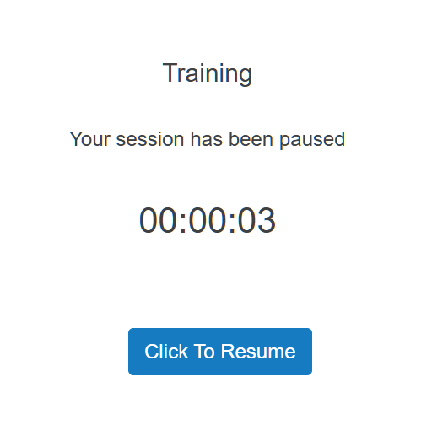
To set a limit navigate to Settings -> Organization Settings -> Agent Settings
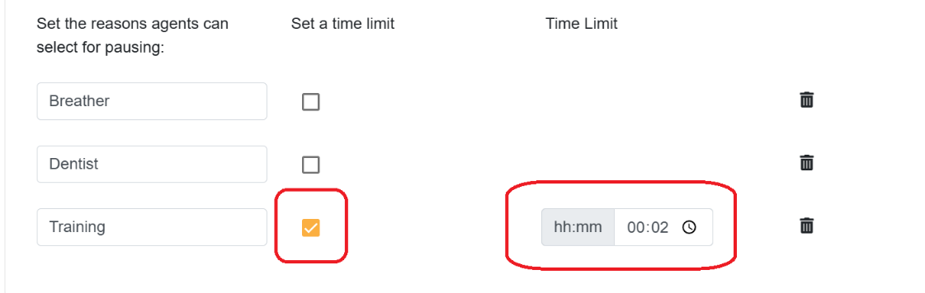
The pause screen will be updated to reflect the limit:
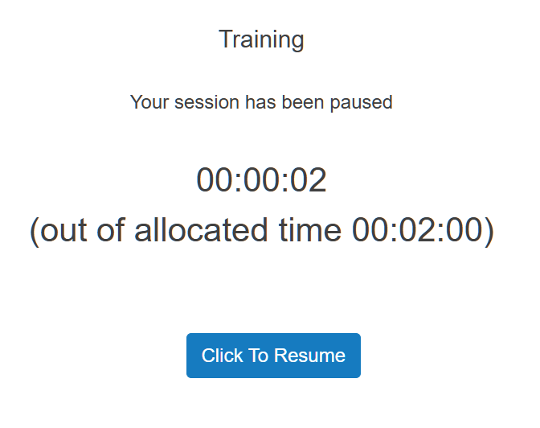
This is purely informational for the agent.

Download Report buttons will show that there is a download being prepared
The buttons to download any reports will be disabled and show a spinner while the report is being prepared

Setting to allow all customer references to be updated
SETTINGS - ORGANISATION SETTINGS – AGENT SETTINGS
Previously any system-set customer references would not allow the agent to change them
Note that there is a limit of 20 characters for a customer reference. This was previously being silently ignored and the customer reference truncated to 20 characters. Now any customer reference longer than 20 characters will have it truncated to 17 characters and *** appended.

Option to BCC all email sent from the system
Navigate to Settings -> Organizational Settings and choose the ‘Settings’ tab.
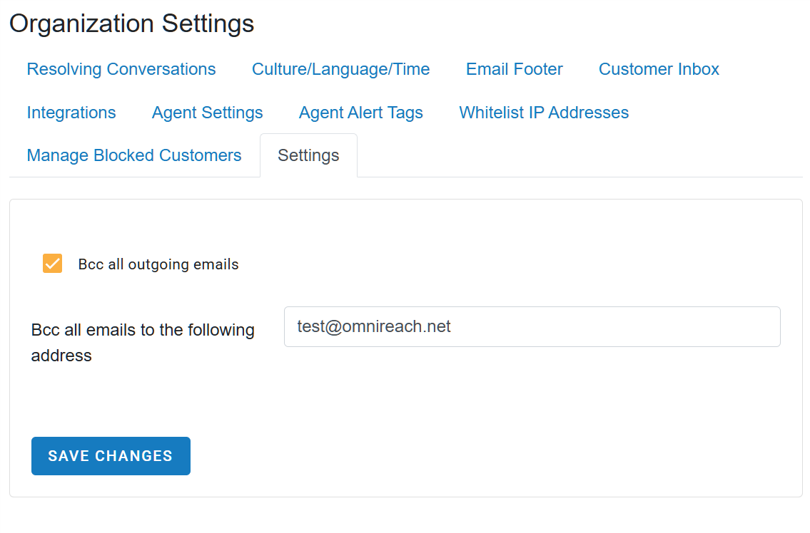
All emails sent from the system will also be BCCed to the address entered. Note that the charge for emails will be doubled

Tag Adjusters based on Team Membership
It is now possible to set Tag Adjusters based on team membership. To add a tag adjuster navigate to Settings -> Team Management and select the ‘Team Tag Adjusters’ tab.
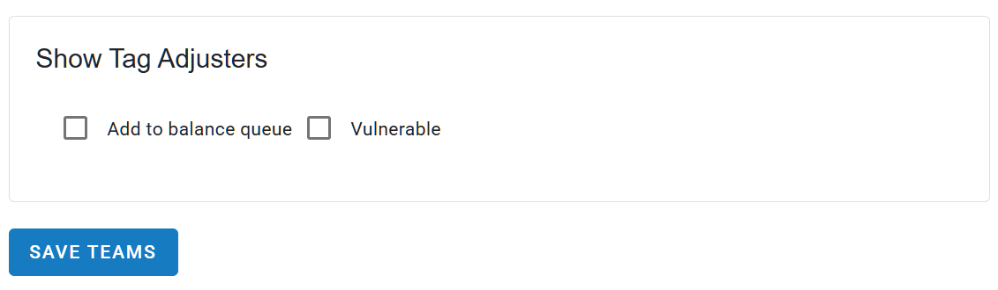

SLA Performance report allows drilling down to chats
This is only available by queue. If there are any conversations where the SLA has been breached then the cell in the Sla Breached column will be clickable.
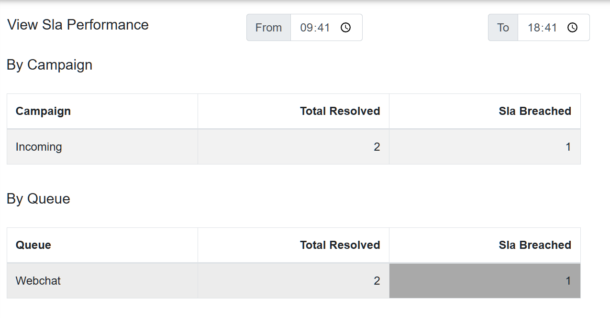
Clicking the cell will expand it to show details of the conversations.
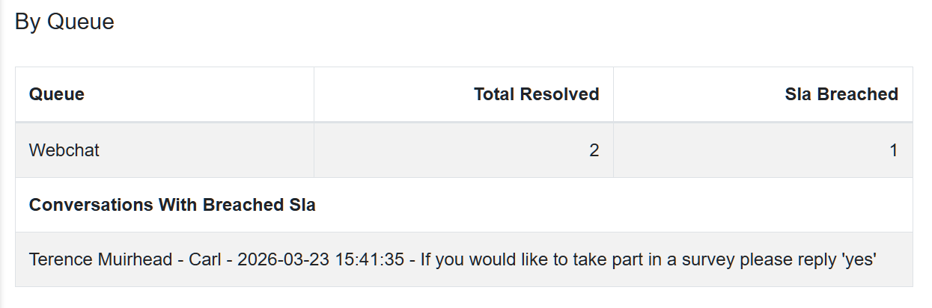,
Clicking on any of the conversations shown in the detail will show a screen showing the list similar to the agent screen for further investigation
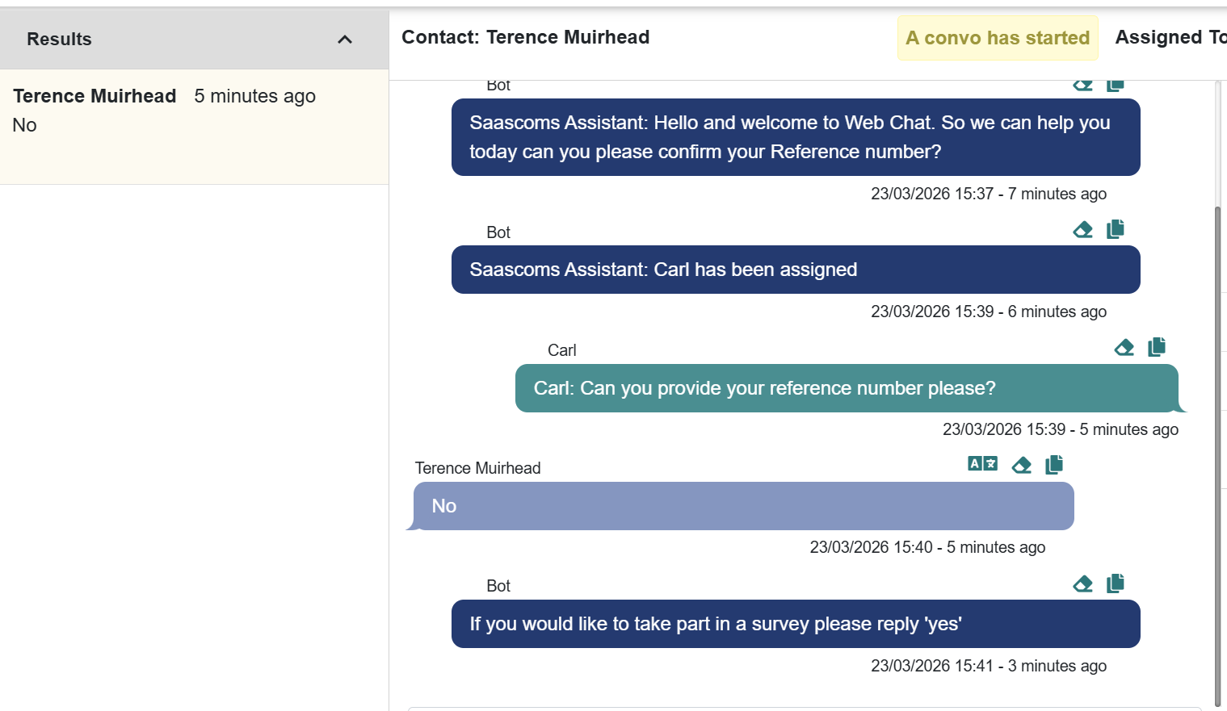

Add a weekly option for Transcript Reports
There is a new ‘Weekly’ setting for transcript reports. By selecting this setting there will be one transcript report delivered weekly.
The report will be generated at Midnight on Sunday, British Standard Time, and will have any conversations that were resolved in the past week.

Known Bugs and Limitations
None

