

Omni Reach – Release Note
Notes Dated: 08/06/2026
Physical Release Date: 28/06/2026

Introduction
The document communicates the new features and changes in OMNI Reach release.

About the Release
*PLEASE NOTE* most changes to the SLA reports will not be retroactive and will only report correctly based on chats started after this release
Changes made include:

ID & V handles two-digit dates better
10/02/32 was being interpreted as 10/02/2032. The logic now looks at both the date on file and the entered date and will match them if as below.
Date on file | Customer entered date | Result
01/01/32 | 01/01/32 | Match
01/01/32 | 01/01/1932 | Match
01/01/32 | 01/01/2032 | Match
01/01/1932 | 01/01/32 | Match
01/01/1932 | 01/01/1932 | Match
01/01/1932 | 01/01/2032 | Not matched
01/01/2032 | 01/01/32 | Match
01/01/2032 | 01/01/1932 | Not matched
01/01/2032 | 01/01/2032 | Match

For this to work you will need to set your date format for the DOB field. Please ensure both formats are entered separated with a comma so….d/M/yy,d/M/yyyy as seen below (next page)
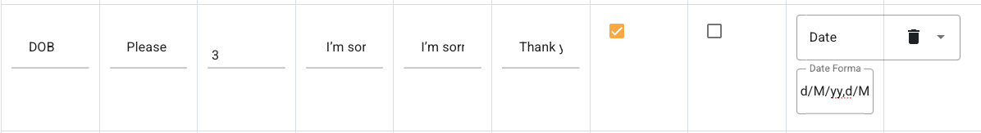

Can set minimum number of correct answers for ID & V
When using variable datasets that may or may not have data for each question this setting will allow setting the minimum number of questions to ask in cases where there is more data than the minimum required. E.g. there are 6 questions, all with data, and the minimum setting set to 3 – the system will ask 3 questions and then continue (assuming all answers are correct)
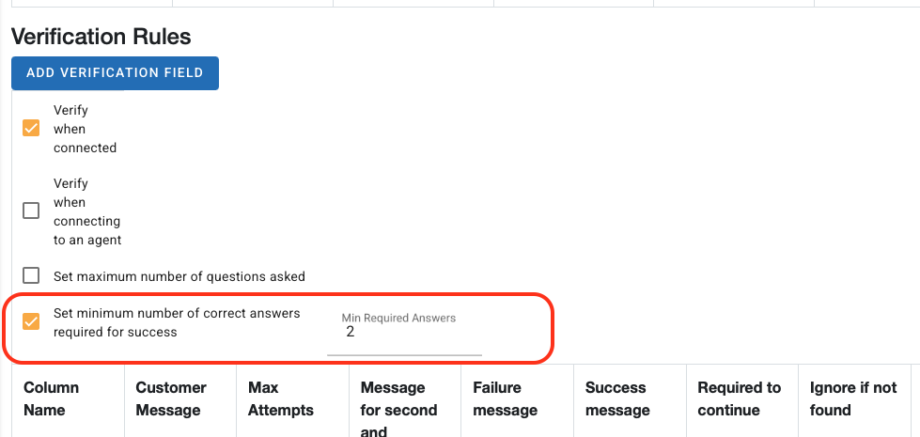
*NB. If any of your fields are set to “Required to continue” the number of these fields cannot exceed to set minimum number of answers for success

Can label queues and campaigns and can filter some reports by label values
The campaign setting is at: Settings -> Campaign Management -> Settings tab
The queue setting is at: Settings -> Queue Setup -> Queue Reporting Labels tab
These are custom labels that will allow you to customize reports that use them. They can be used for any purpose.
General Reports that have the new filter:
- Dashboard
- Campaign
- Incoming
- SLA performance

Campaign closed time is no longer added to wait times
Prior to this change if a message comes in while a campaign is closed the time will start ticking from the time that the message arrives. After the change the timer will only tick while the campaign is open. E.g. a message comes in during the campaign closed time and an agent replies to the message 2 minutes after the campaign opens but 5 hours after the message was received, then the wait time for the chat would be 2 minutes.

Added bulk assign tab for unworked chats
The bulk assign screen has a new tab ‘Unworked’ that will show any chats with no agent replies.

Team manager dashboard drilldown
Clicking on Replies, Assigned or Resolved cells will expand to show current chats with the related attributes. E.g. User A Assigned will show all chats *currently* assigned to User A. The number of chats may be different to the figure shown if the report dates go outside of the retention period.

Transcript report adds dynamic reporting values
The Transcript download report can now include the dynamic labels (2.3 above). This can be used to further filter the report either in client systems or Excel. The transcript reports only output the Campaign values.
To download a report with the values select the following checkbox in the preparation screen:
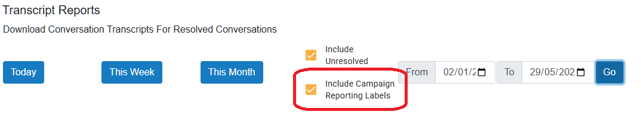

Added agent filter to some reports
It’s possible to filter the reports by agent.
Reports include:
- Agent Status
- SLA Reporting

Added date range to SLA performance report
It is now possible to search in a date range in the ‘All’ tab.

Added agent section to SLA performance report
It is now possible to see SLA performance by agent in the ‘By Agent’ tab

If a user does not have access to a queue or chat the messaging is better
E.g. if the chat has been resolved and the queue does not show resolved chats, or if the chat had already been assigned to another agent. Previously the page would show the loading animation indefinitely.

Agent Profile report can show other team members
There is a new setting in the Team Management page in the ‘Reporting’ tab. This will allow team members the ability to see their teammate’s SLA performance in Profile -> Reports

Changes to Webhook

Agent Replied activity
BreachedSla (bool) has been added

Resolved activity
Agents (array of strings) has been added. These are the agent ids

Known Bugs and Limitations
None

