

Omni Reach – Release Note
Notes Date: 16/08/2026
Release date 06/09/2026

Introduction
The document communicates the new features and changes in OMNI Reach release.

About the Release

BUGFIX: Fix for website crash
Random crashes for the website and crashes when going directly to a chat have been fixed.

BUGFIX: Sometimes the oldest message in a queue was not sorting correctly

BUGFIX: A message is now shown when no tags are available to be added to a chat

There is a team setting to make HTML replies the default for email chats
When this setting is enabled any agents in this team will have the HTML editor enabled by default for email replies.
This setting can be enabled in the Team Management pages. After selecting the team choose the ‘Settings’ tab and enable the option.
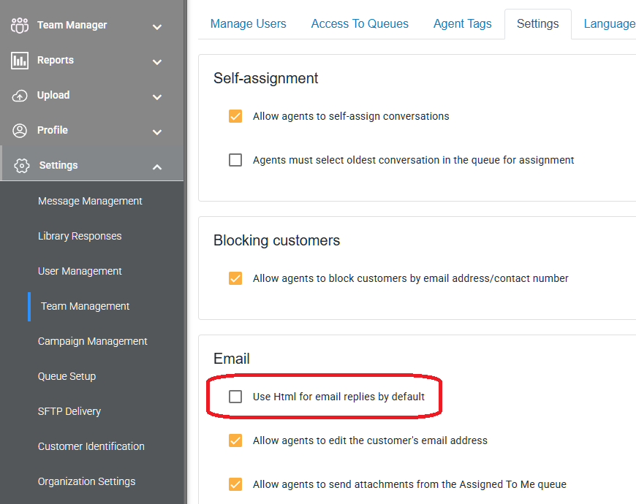

It is now possible to tag the response to a Question Action if the customer doesn’t respond with any of the provided answers
The question action has been enhanced with a new option to tag the conversation when the customer answers with a different answer than the options supplied. In the example below the conversation will be tagged with ‘NotAnswered’ if the customer ignored the prompts and wrote ‘I want to make a payment’
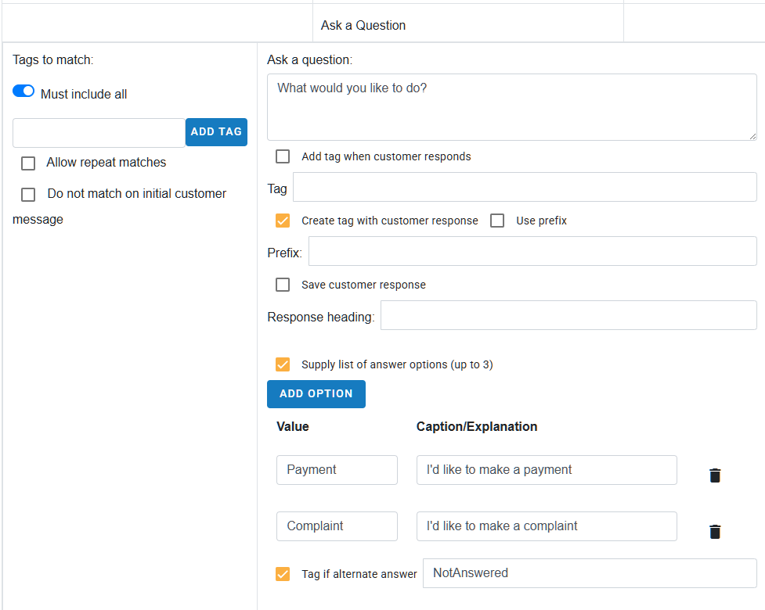

A new analyzer is available for emails
The analyzer is called ‘Email Analyzer’
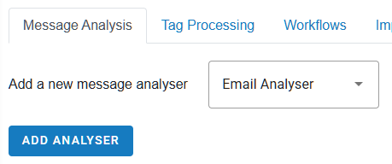
There are options to analyze the From address, the To or CC addresses, or the subject. Combinations of the options can also be entered (eg when there’s an email from a certain address sent to a certain address)
For each option selected it is possible to find an exact match or a partial match. A partial match is useful if you are e.g. looking for email from a certain company, but don’t mind who sends it, or a subject that contains key words but also a customer reference.
The analyzer has a switch to either require *all* conditions to be met, or any of them.
Any conditions: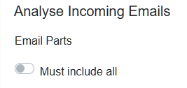

All conditions: 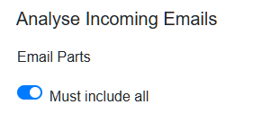

The configuration below will match if the sender has an email address with the @client.com domain, and the subject of the email contain ‘Direct debit’ anywhere in the subject.
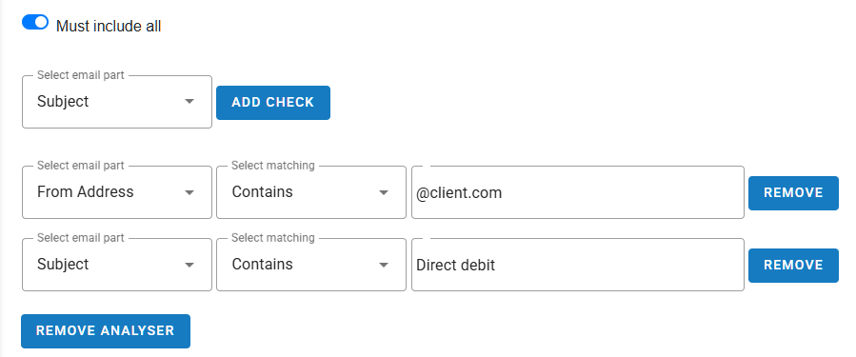

There is a new organization option to prevent agents from unassigning chats
This setting can be enabled in the Organization Settings page in the ‘Agent Settings’ tab. The setting is called ‘Do not allow agents to Unassign chats’
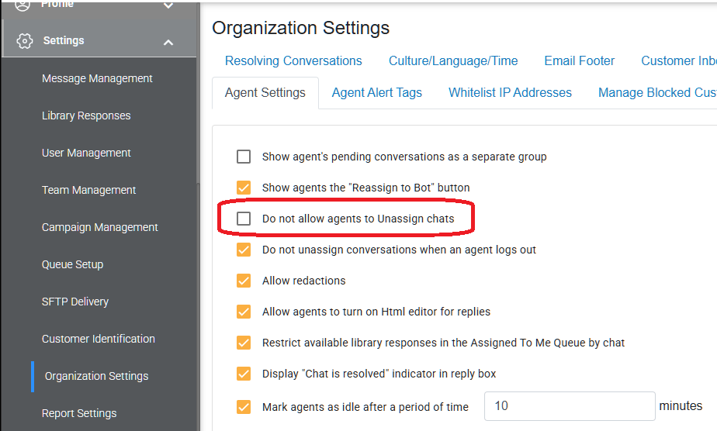

Known Bugs and Limitations
None

